### Linux Installation (ubuntu)

#### Step 1: Check if Python3.6 is Installed

Open the terminal and type in python3.6.

| $ python3.6 |
| --- |

If you get the following error:

| python3.6: command not found |
| --- |

it means that Python is not installed - follow the next steps in this section for installation instructions.

The console may give you a message that Python is not installed, followed by a command that will install it for you. In that case, follow the instructions in the console.

If it does not give an error, it means you have python3.6 installed and you can move on to the **Installing Third-Party Modules** section below.

#### Step 2: Install Python3.6

On the terminal copy the following individual commands on your console.

| $ sudo add-apt-repository ppa:jonathonf/python-3.6 $ sudo apt-get update $ sudo apt-get install python3.6 |
| --- |

When prompted put in your password and leave the commands to run.

#### Step 3: Confirm Installation

On the terminal type in python3.6. If the output looks like this, it means that Python has installed successfully.

| $ python3.6 |
| --- |

| Python 3.6.0 (default, Nov 17 2016, 17:05:23)  [GCC 5.4.0 20160609] on linux Type "help", "copyright", "credits" or "license" for more information. >>> |
| --- |

To get out of this interface use the exit() function like this:

| $ python3.6 >>>exit() |
| --- |

Now go to Installing third party modules below.

### Mac Installation

#### Step 1: Check if Python3.6 is Installed

Open the terminal and type in python3.6.

| $ python3.6 |
| --- |

If you get the following error:

| $ python3.6 |
| --- |

it means that Python is not installed - follow the next steps in this section for installation instructions.

If it does not give an error, it means you have python3.6 installed and you can move on to the **Installing Third-Party Modules** section below.

#### Step 2: Download Python3 latest release

Go to the [Downloads page](https://www.python.org/downloads/) on the Python website and download the latest release of Python 3 by clicking the button at the top of the page.

#### Step 3: Install Downloaded File

Install the downloaded file by following the installation instructions that follow.

#### Step 4: Confirm Installation

On the terminal type in python3.6. If the output looks like this, it means that Python has installed successfully.

| Python 3.6.0 (default, Nov 17 2016, 17:05:23) Type "help", "copyright", "credits" or "license" for more information. >>> |
| --- |

To get out of this interface use the exit() function like this:

| $ python3.6  Python 3.6.0 (default, Nov 17 2016, 17:05:23)  [GCC 5.4.0 20160609] on linux Type "help", "copyright", "credits" or "license" for more information. >>>exit() |
| --- |

### Installing Third-Party Modules

Other than the built-in standard library of modules, Python developers have created their own modules to further extend Python's functionality.

The best way to install these Python modules is to use Python's **pip** tool. Pip is a tool for installing and managing Python packages, many of which are found in the [Python Package Index](https://pypi.python.org/). It's kind of like a free application store for Python modules.

#### Installing pip3

Pip comes installed with Python on Mac when you install Python3.

For Linux, run this command:

| $ sudo apt-get install python3-pip |
| --- |

Alternatively, if you run into any error using the above command you can use the following:

This command downloads the script that we will use to install pip.

| $ sudo curl https://bootstrap.pypa.io/get-pip.py -o get-pip.py |
| --- |

Then, using python3.6, we run the downloaded script to install pip.

| $ sudo python3.6 get-pip.py |
| --- |

Once installations are done, we can move on and start learning some Python.

# Windows installation

### Step 1: Download the Python 3 Installer

1. Open a browser window and navigate to the [Download page for Windows](https://www.python.org/downloads/windows/) at [python.org](https://www.python.org/).
2. Underneath the heading at the top that says Python Releases for Windows, click on the link for the Latest Python 3 Release - Python 3.x.x. (As of this writing, the latest is Python 3.6.5.)
3. Scroll to the bottom and select either Windows x86-64 executable installer for 64-bit or Windows x86 executable installer for 32-bit. (See below.)

#### Sidebar: 32-bit or 64-bit Python?

For Windows, you can choose either the 32-bit or 64-bit installer. Here’s what the difference between the two comes down to:

* If your system has a 32-bit processor, then you should choose the 32-bit installer.
* On a 64-bit system, either installer will actually work for most purposes. The 32-bit version will generally use less memory, but the 64-bit version performs better for applications with intensive computation.
* If you’re unsure which version to pick, go with the 64-bit version.

Note: Remember that if you get this choice “wrong” and would like to switch to another version of Python, you can just uninstall Python and then re-install it by downloading another installer from [python.org](https://python.org/).

### Step 2: Run the Installer

Once you have chosen and downloaded an installer, simply run it by double-clicking on the downloaded file. A dialog should appear that looks something like this:

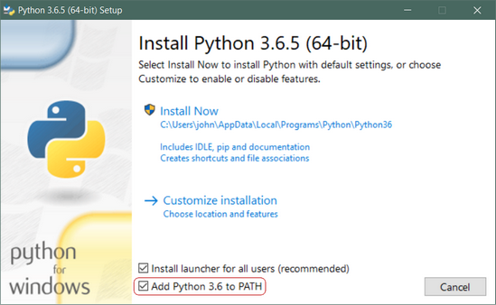

Important: You want to be sure to check the box that says Add Python 3.x to PATH as shown to ensure that the interpreter will be placed in your execution path.

Then just click Install Now. That should be all there is to it. A few minutes later you should have a working Python 3 installation on your system.